| EX NO :3B  DATE:08/08/23 | Implement a Multilayer Perceptron for classification in Keras |
| --- | --- |

**Aim:**

To Write a program to implement the simple problem like classification in keras

**Procedure:**

* Import the dataset into the python environment and load the dataset
* Check the null values and create a model
* To split the dataset into train and test using scikit learn package
* Install the tensorflow package in the python environment
* Create a model using the tensorflow and import keras package
* To compile the model and fit with correct epochs
* To predict the model and check the accuracy score

**Program:**

**Importing the packages**

import numpy as np

import pandas as pd

data=pd.read_csv("/content/Raisin_Dataset (1).csv")

data

**Output:**

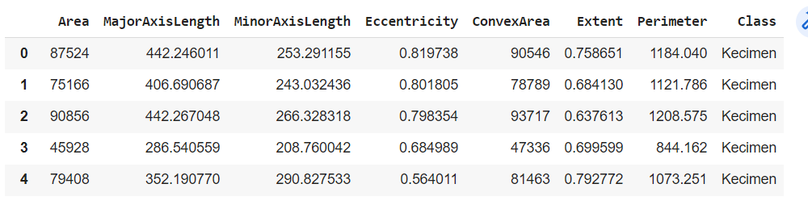

**Checking the null values**

data.isnull().sum()

**Cleaning the Data**

from sklearn.preprocessing import LabelEncoder

le=LabelEncoder()

data['Class']=le.fit_transform(data['Class'])

data

**Output:**

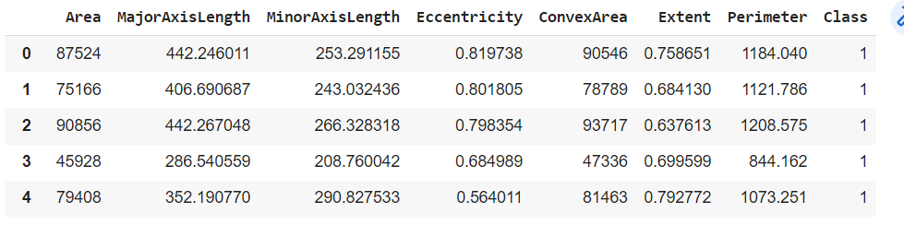

**Splitting the train and testing data**

x=data.iloc[:,1:7]

x

y=data.iloc[:,-1:]

y

Output:

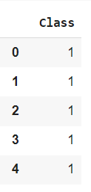

from sklearn.model_selection import train_test_split

x_train,x_test,y_train,y_test=train_test_split(x,y,train_size=0.75)

**Creating a model using keras package**

from tensorflow import keras

model=keras.Sequential()

model.add(keras.layers.Dense(100,input_dim=6,activation='relu'))

model.add(keras.layers.Dense(600,input_dim=100,activation='relu'))

model.add(keras.layers.Dense(800,input_dim=600,activation='relu'))

model.add(keras.layers.Dense(900,input_dim=800,activation='relu'))

model.add(keras.layers.Dense(2,input_dim=900,activation='sigmoid'))

model.summary()

**Output**:

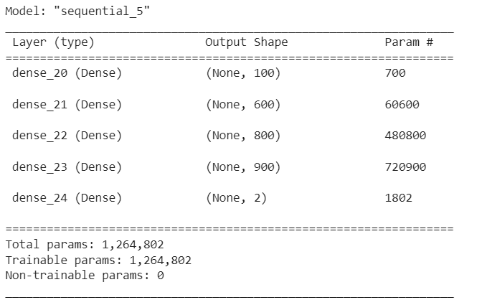

model.compile(optimizer='adam',loss="sparse_categorical_crossentropy",metrics="accuracy")

**Fit the model**

model.fit(x_train,y_train,epochs=100)

Output:

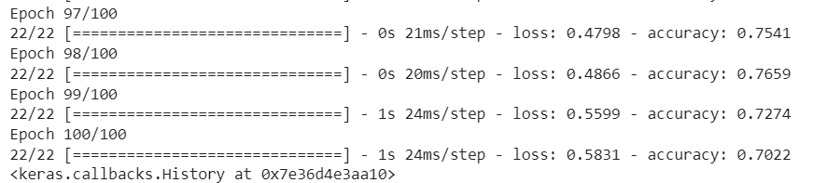

y_pred=model.predict(x_test)

y_pred=[np.argmax(i) for i in y_pred]

**Check the accuracy of the model**

from sklearn.metrics import accuracy_score

accuracy_score(y_test,y_pred)

Output:



**Confusion matrix**

from sklearn.metrics import confusion_matrix

confusion_matrix(y_test,y_pred)

**Output:**



import seaborn as sns

sns.heatmap(confusion_matrix(y_test,y_pred))

**Output:**

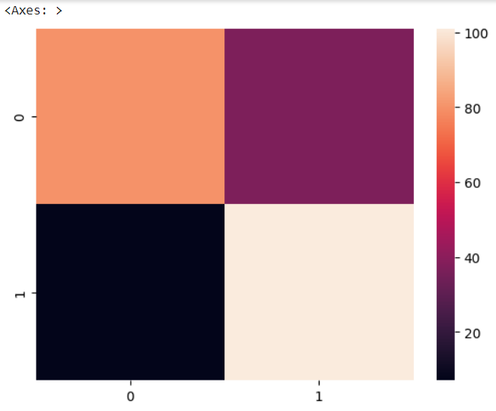

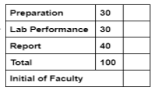

**Result:**

Thus the Implementation of simple program like classification using keras is successfully executed